Table of Contents

Chapter1 Overview 1

1.1Introduction 1

1.2 Background 1

1.3 Description of the proposed system 1

1.4 Features of project 1

Chapter2 Scope 2

2.1 Aims: 2

2.2 objectives: 2

Chapter 3: Development methodology 3

Design pattern 5

Chapter 4 Project planning 6

4.1 WBS (Work Breakdown Structure) 6

4.2 Time Estimation 8

4.3 Milestones 8

4.4 Schedule/Gantt chart 10

Chapter 5 Other project activities 12

5.1 Risk management 12

5.2Configuration Management 14

Chapter 6 Conclusion 15

Chapter 7 References: 16

# 

# Chapter1 Overview

## 1.1Introduction

Here, the topic of the project is researched and chosen as “Online Bazzar”. Which is an online business site. This site primarily offers the web based shopping of excessive dresses, devices, accessories and pretty much whatever else Online shopping is the way toward purchasing items through web without going to store or shop's area physically. Here individuals utilize their credit/charge or other bank card for installment.

It was hard to purchase the items wandering in the market a really long time in prior time. It will be so hard to go to the market in the event that he/she have a busy timetable This site esteemed the less consuming time. Information will be kept secretly m reasonable.

The project is build up with the utilization of the most prevalent web programming language PHP. This builds up the ability of programming in PHP language and creates a complete system without blunder. So the learning of other module of the course will likewise be used to build up the total venture.

## 1.2 Background

Everything will be computerized with regard to current circumstance. It will quickly be becoming so prevalent in this present days. it will facilitate the general population to purchase the item anything they desire through the web without going in group bargaining by any means. Additionally, it will be valuable to send the blessings to the relatives through web. It will decrease the time who are for the most part occupied in their day by day life.

## 1.3 Description of the proposed system

Online Bazzar is one of the web based online dealing system where various customers can easily surf the website contains new product with their prices. Your own data and the data of client can be kept safely and with proper managed. By using the HTML, PHP, CSS java script I am going to developed as well design website where you have to sign up and to view the details user should have user name and password. The user can browse various data once he/she is logged in. “Online Bazzar “you can contact us whatever you like on the website.

## 

## 1.4 Features of project

The main features of the “Online Bazzar” (Online website) which I’m going to develop in coming days are listed below:

* A complete web-based application is built.
* A documentation that includes all the project contents.
* A platform that office employee posts their new items with fix price.
* A platform for the customer to search and apply for various products.
* Login system for company and employee
* Highly secure login system
* Long term persistency using MySQL database
* Messaging and notification
* Error free system with high usability.
* Highly refined and easy to use user interface

# Chapter2 Scope

Project scope is a part of project planning that involves determining and documenting a list of specific project goals, tasks, costs. It also characterizes the majority of the work done to be finished amid the undertaking the scope describes. It characterizes the end product to be conveyed to the client by a specific point in time and at a predetermined spending plan or cost. Customers can examine diverse items and select the sensible one. items/things will be given inside reasonable rate. It's faster and reliable way to deal with request your item. The customer will have the ability to use the application to play out their requesting the items from wherever.

## 2.1 Aims:

The aims of my project which will be further developed are as listed below:

• The aim of the project is to develop a complete website which have better interactive feature in Online Bazzar in Nepal.

• To develop a document that will include every aspect of development.

• It facilitates to the physically challenged people and who have busy schedule.

• It is easier and reliable.

• To manage user data in efficient and effective way

## 2.2 objectives:

• To develop a complete error free “Online Bazzar” website.

• To get familiar with the web programing language and utilize the idea here.

• To use the information of each module to create single vast task.

• To secure information in database.

• data redundancy should be reduced.

• Make plan and actualize it.

• Test the created framework.

• Remove any blunder and take client inputs.

# Chapter 3: Development methodology

The waterfall methodology is used to develop the “online Bazzar”(Online business website). Waterfall mode is the orderly methodology where each stage must be finished to go to other steps. Waterfall model is most appropriate in situation where the undertaking size is little, and the prerequisites are as of now known and won't be changed in future (www.tutorialspoint.com, 2019). This model is best for web application advancement and fits better with the framework that utilizes database framework.

**Advantage:**

• It takes into account departmentalization and administrative control.

• Simple and straightforward.

• Stages are handled and finished each one in turn.

**Drawbacks:**

• It doesn't take into account much reflection or revision.

• No working programming is delivered until late amid the existence cycle.

• High measures of hazard and vulnerability.

• Poor model for long and continuous activities.

The steps which I will use are listed below:

* Strategy and planning
* Feasibility study
* Analysis
* Design
* Implementation
* Maintenance

The reasons behind choosing the waterfall model are as described below:

• The project which I’m going to develop is small.

• There are no ambiguous prerequisites.

• Technology is comprehended.

• planning undertakings and time estimation additionally appears to be simple.

Strategy and planning

Feasibility study

Analysis

Design

Implementation

Maintenance

Fig: Waterfall model

# Design pattern

In software building, a design pattern is a general repeatable answer for a normally happening issue in programming structure. A design pattern is anything but a completed structure that can be changed legitimately into code (Sourcemaking.com, 2019).

Here, in my project I will use the MVC design pattern. MVC design pattern is one of the most established building design for the web applications. Basically it is utilized to isolate the logic of various layers in a system in free units and also known as rule of separation of concern (JournalDev, 2019). I choose this pattern in my project, since change doesn't influence the whole model just as help improvement of SEO cordial pages. Object oriented method is drawn nearer here in the project.

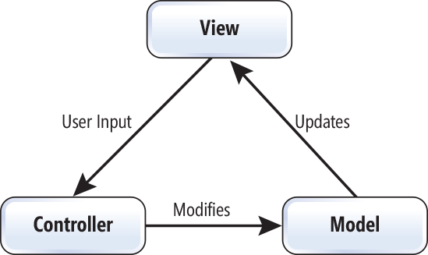

Fig: MVC design pattern

• Model - Model represent an object conveying information. It can likewise have rationale to refresh controller if its information changes.

• View - View speaks to the representation of the information that demonstrate contains.

• Controller - Controller follows up on both model and view. It controls the information stream into model item and updates the view at whatever point information changes. It keeps view and model isolated.

# Chapter 4 Project planning

## 4.1 WBS (Work Breakdown Structure)

It is fundamental as a major aspect of a project lifecycle and course of events. Basically, WBS is the process of dividing of complex project to less difficult and manageable tasks (www.tutorialspoint.com, 2019). For the most part, the project chiefs utilize this strategy for improving the undertaking execution. In WBS, a lot bigger undertakings are separated to sensible lumps of work. These pieces can be effectively directed and evaluated. The goals of developing a WBS are:

• It facilitates collection of various information about work done that needs to be done for a project.

• For the project group to proactively and sensibly plan out the task to finish.

• To sort out activities into reasonable segments that will accomplish project targets.

Some of the benefits of using WBS in a project are as follows:

• it gives the project team member a comprehension of where their pieces fit into the general project the executives plan

• It provides a basis for estimating staff, cost and time.

• The complete work to be done by the project is identified.

• It facilitates to provide clear status report on project progress.

Coding

Integration Testing

White box testing

Black box Testing

Uniting testing

Database

Behavioral Model

Structural Model

Architecture

Feasibility Study

Testing

Implementation

Design

Analysis

Project Proposal

Online Bazzar

Final

Documentation

Scope

Final Report Submission

Planning

UI Design

Monitories

The work breakdown of the project is demonstrated by the above figure and represents the task is separated in the six distinct parts. Project proposal is set in the first stage of the project through which a good planning can be done. After my proposal submission I will do the analysis part of the undertaking which will be the initial step after the proposal submission. Analysis helps to highlight the necessary elements involved in the project and the elements that should not be included in the project. In analysis stage there are two sub groups which will help to collect the necessary requirement for the project and various diagrams will be drawn like Use case, initial class diagram. After this the designed part of the project will be focused and design up the application. The design will make easy to use and progressively attractive. Attractive web application can get eyes of the customers which is beneficial for the online business. With this I will do coding and the design specification in the implementation part this is where I will build up the application. After this, I will do the testing part on the grounds that there might be minor bugs, which I may have done in the coding time. I will do Integration, black box, White box Unit testing. This will let realize that the site that I have planned is useful or not. Likewise, toward the finish of the work breakdown, I will do the documentation part. This part will assist other individuals with understanding about the application. They will give the insight about the application that I have structured through documentation.

## 4.2 Time Estimation

Assessing time will enable you to consent to the due dates you set and, by adhering to them, you will surely be progressively solid and dependable. The project will be increasingly exact if you analyse from “bottom up”. Breaking of larger and complex tasks into detailed tasks and then the time needed to complete each one task should be estimated.

|  |  |  |
| --- | --- | --- |
| **WBS** | **Task name** | **Days** |
| **1** | **Project proposal** | **16** |
| 1.1 | Scope | 8 |
| 2 | Planning | 5 |
| 2.1 | Monitories | 3 |
| **2.2** | **Analysis** | **28** |
| 2.3 | Feasibility study | 10 |
| 3 | Architecture | 18 |
| **3.1** | **Design** | **25** |
| 3.2 | Structural Model | 5 |
| 4 | Behavioural Model | 6 |
| 4.1 | UI design | 14 |
| **4.2** | **Implementation** | **20** |
| 5 | Database | 11 |
| 5.1 | Coding | 9 |
| **5.2** | **Testing** | **7** |
| 6 | Unit testing | 2 |
| 6.1 | Black box Testing | 2 |
| 6.2 | White box testing | 2 |
| 7 | Integration testing | 1 |
| **7.1** | **Final Documentation** | **11** |
| 7.2 | Final report submission | 6 |

## 4.3 Milestones

A project milestone is an administration device that is utilized to outline a point in a project schedule. Basically milestone marks are used to conversion of a project from one phase to another and can be utilized to symbolize whatever has begun or completed, however it's principally utilized as a scheduling tool.

In the context of project management Milestones are used as:

• The beginning of appreciable periods of work

• The end of significant periods of work.

• It is used to mark the project deadline.

• Identifies critical path.

• It facilitates by making easier for the identification of important dates.

Milestones are one of the parts of a Gantt chart and are appeared on the diagram as a precious stone:

|  |  |  |
| --- | --- | --- |
| S. N | Milestones | Date |
| 1 | Project proposal | 9th April, 2019 |
| 2 | Analysis | 8th May, 2019 |
| 3 | Design | 3rd June, 2019 |
| 4 | Implementation | 24th June, 2019 |
| 5 | Testing | 1st July, 2019 |
| 6 | Final Documentation | 12th July, 2019 |

Fig: Milestones

The project analysis has begun and completed on May 8th. Design steps of the project will be completed on 3rd June and the testing will be finished on July 1st since the deadline for the project is 12th July 2019.

# 4.4 Schedule/Gantt chart

Scheduling of the project refers to the time table of the work. Gantt chart helps to plan, coordinate and facilitates better communication and shows the working procedure and its progress over a certain period of time and considers factors, for example, constrained resources and assessing vulnerability. Here we are utilizing the Gantt diagram utilizing the Project libre.

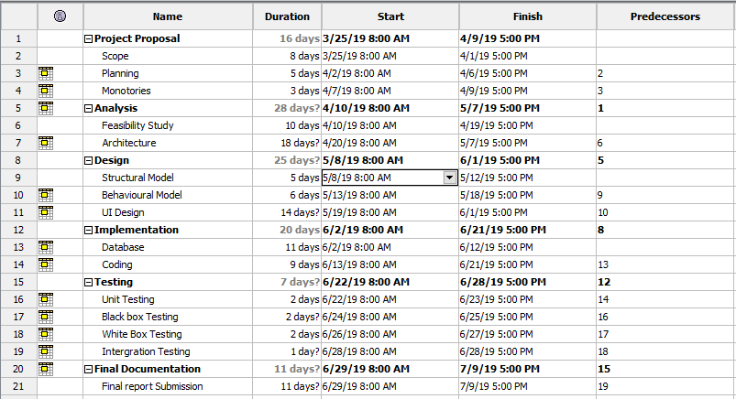

Fig: Gantt Chart

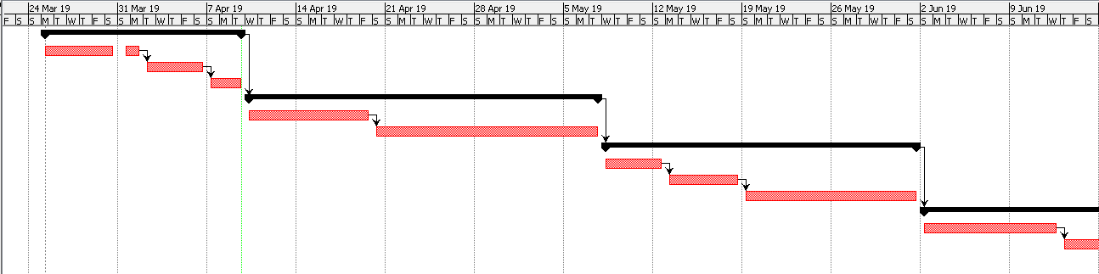

Fig: Gantt Chart

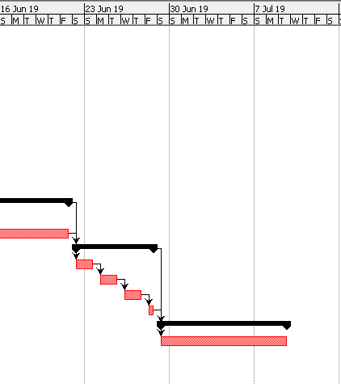

Fig: Gantt Chart

# Chapter 5 Other project activities

## 5.1 Risk management

Risk is the point at which an uncertain event or condition can happen and affect the project result. It could affect the people, processes, technology related to the whole project. Due to this uncertainty, project hazard requires serious preparation so as to oversee them effectively.

In this project likewise there may be a portion of the risk factor that must be investigate by me to result the best task.

So that we can calculate the risk management impact = Likelihood* Consequences.

The three choices of risk likelihood are listed below:

|  |  |
| --- | --- |
| **Likelihood** | **Value** |
| Low | 1 |
| Medium | 2 |
| High | 3 |

Fig: Likelihood Risk Values

Also listed five consequences of the

|  |  |
| --- | --- |
| **Consequences** | **Value** |
| Very low | 1 |
| Low | 2 |
| Medium | 3 |
| High | 4 |
| Very high | 5 |

Fig: Consequences

|  |  |  |  |  |  |
| --- | --- | --- | --- | --- | --- |
| SN | Risks | Likelihood | Consequence | Impact | Actions |
| 1 | Failure of Hardware | 3 | 3 | 9[3*3] | Proper maintenance |
| 2 | Natural Disaster | 1 | 3 | 3[1*3] | Backup for files |
| 3 | DDOS Attack | 2 | 3 | 6[2*3] | Powerful server should be used |
| 4 | Theft or Robbery | 2 | 3 | 6[2*3] | Password protected or backup |
| 5 | Failure in the time schedule | 1 | 3 | 3[1*3] | Proper planning should be made |
| 6 | Project requirements may not be found easily | 3 | 1 | 3[3*1] | Looks for various website, teachers, seniors. |

Fig: Risk Management

## 5.2Configuration Management

Project management helps to provide processes and system for managing, protecting and controlling all the project products. It checks that proposed changes are deliberately considered to limit adverse impacts. It improves execution, dependability, or viability; expand life; lessen cost; diminish hazard and obligation. All of the records related to the assignment is kept in one drive in made way so it will be anything besides hard to get to and find any envelope we require. All of the data related to the assignment like proposal, examination, layout, documentation of endeavor, testing and report will be secured in the envelope named "Online Bazzar”.

# Chapter 6 Conclusion

Ultimately the "Online Bazzar” is finished with utilization of the distinctive programming dialects apparatuses like Script, CSS, HTML, PHP, PhpMYSQL. This site t it makes simpler to the client just as easy to use where they can see the various product details and order the product /Item easily. Risk management is done to decrease the hazard when building up the site. Gantt chart additionally delivered to list and schedule. By utilizing this site client feel so natural and don't hesitate to utilized it is solid.

# Chapter 7 References:

www.tutorialspoint.com. (2019). *Work Breakdown Structure*. [online] Available at: https://www.tutorialspoint.com/management_concepts/work_breakdown_structure.htm [Accessed 8 Apr. 2019].

JournalDev. (2019). *MVC Design Pattern - JournalDev*. [online] Available at: https://www.journaldev.com/16974/mvc-design-pattern [Accessed 8 Apr. 2019].

Sourcemaking.com. (2019). *Design Patterns and Refactoring*. [online] Available at: https://sourcemaking.com/design_patterns [Accessed 8 Apr. 2019].

www.tutorialspoint.com. (2019). *SDLC Waterfall Model*. [online] Available at: https://www.tutorialspoint.com/sdlc/sdlc_waterfall_model.htm [Accessed 8 Apr. 2019].